
How to view lap times and rosters on your phone (iPhone only)

- Download RaceHUB from the App Store
- Enter the username and password for each trike to see their information:
Username | Password
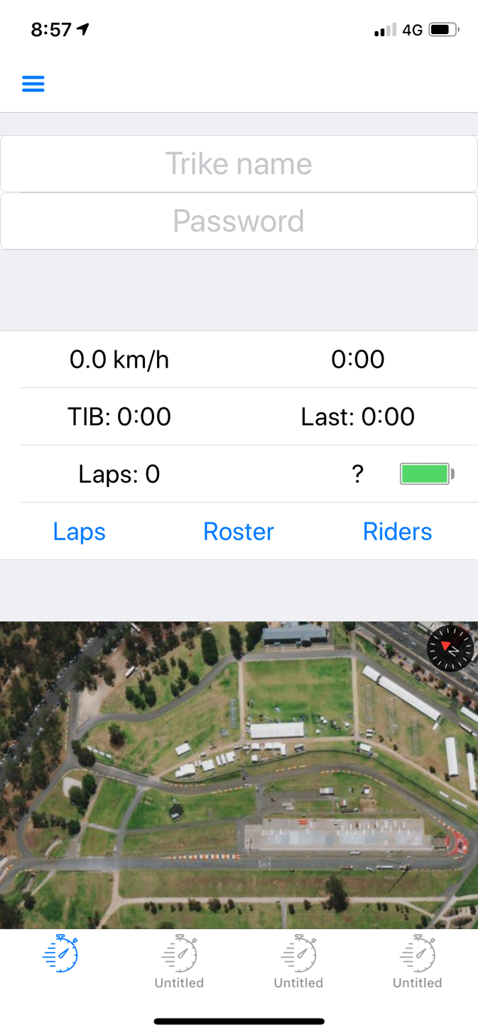
Log in to view information
See all lap times
Roster with estimated riding times
Load multiple trikes at the same time
See all live GPS location

